- 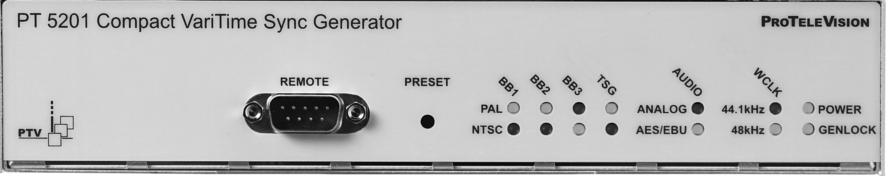

- VariTime™, 8 fields for PAL
- VariTime™ 4 fields for NTSC
- Master applications with internal high stability reference
- Genlock to PAL, NTSC or 10 MHz clock, for slave applications
- Multistandard: 525/60, 625/50 and dual standard operation
- Outputs:
3 Black Burst
1 Colorbar/BlackBurst
1 SDI Colorbar/Blackburst
1 AES/EBU or Analog Audio
1 WordClock at 44.1 or 48 KHz
- Configuration via Windows interface
- Direct frontpanel access for operation and 4 presets status
- 1U, half 19” wide and rackmountable

Compact Varitime TM Sync Generator,
PT 5201

Application
The new digital studios need cost efficient and reliable synchronization for the main equipment to work reliably.
For this purpose PTV offers a fully integrated solution eliminating any costs associated with modular structures, support of many different signal types and fancy operating features.

All solutions have been carefully designed to meet all requirements for the modern studio and editing setups.

PTV introduces a Sync Generator as the first of its type ever seen!
The PT 5201 includes all basic features for professional sync, timing and test signals in one half-sized box.
Configuration
The PT 5201 configuration is based on a well-arranged Windows interface.
The Windows interface makes it easy to manage all timing, patterns and audio features in one screen.
Modification from factory preset can be saved as a file on the PC harddisk or uploaded to the PT 5201 as a setup.
The setup are uploaded to PT 5201 in an instant mode or stored as a preset in the instrument.
Communication between PT 5201 and PC via standard RS-232 protocol, makes it possible to use any kind of PC.
Status of current functions and systems will be displayed at any time as matching LEDs, on the PT 5201 frontpanel.

Master/Genlock Applications
The PT 5201 is designed to manage slave as well as master operations, as a stand alone unit.

In systems where PT 5201 operates as a master the genlock function locks to an internal, high stability TCXO, reference oscillator.
For use in applications where the PT 5201 operates as a slave the genlock function is used.
The genlock function features genlock to NTSC and PAL video signals, BlackBurst house sync or a 10 MHz reference clock, e.g. from a GPS receiver. Further more the genlock function features timing and active loop-trough of the genlock signal.

Analog Outputs
The sync generator is equipped with three VariTimeTM analog Black Burst outputs. Each of these Black Burst outputs is individually fully timeable and can be configured as NTSC or PAL-generator, in any combination.

Analog Test Signals Output
An analog Color Bar generator, configurable in system and timing, is also included. The Color Bar generator provides standard colorbars and testpatterns, according to SMPTE and EBU. For diagnostics in studio setups a list of simple testsignals is available.

SDI Output
The SDI ColorBar output is based on the same digitally generated Analog Test Signal generator and therefore it outputs the same test pattern and timing. The SDI output includes codes for embedded audio, featuring data for 1kHz Stereo and silence.

The SDI signals are in general generated as 10 bit signals, except one of the EBU 75% Color Bar signal which is generated with 8 bit according to ITU 801

Audio generators
PT 5201 contains an Analog Audio Generator as well as an AES/EBU Serial Digital generator. One generator must be selected due to both generators output on the same XLR connectors.

Analog Audio Outputs
The Analog Audio generator provides three different test tones in a number of levels. The output is available in stereo, mono and includes click markers for identification of left channel. The click interval is selectable.

AES/EBU Serial Digital Audio Outputs
The Serial Digital Audio generator provides three different test tones in a number of levels. The output is available in stereo, mono and includes click markers for identification of left channel. The click interval and samplings frequency for the AES/EBU output are selectable. The generator also features system lock and timing facilities.

WordClock Output
The WordClock signal is a continuous reference clock operating at TTL level, used for synchronizing audio equipment. Sampling frequency of 44.1 or 48 kHz is selectable in the audio window.

Presets
Four complete instrument presets have been included to make it simple to change the configuration for different studio setups. Changes between the presets are available from a hidden button at the frontpanel. The number of presets stored in the configuration PC is unlimited.

PRODUCT DATA

Master oscillator
Master Frequency Reference TCXO:
- Temperature drift:0-50°: ± 2,5 ppm
- Aging: ± 1 ppm/year; first year, then better

Remote Control
- Input interface: RS-232 port, 9 pole D-sub, male
- Protocol: SCPI based
- Baud rate: 9600 Kbit

Genlock
- Input: 75 Ω looped trough
Connector:BNC
- Return loss: >36dB to 6 MHz
- Genlock Signal:
Video: PAL, NTSC
Continuous freq.: 10 MHz
- Genlock Video:
Amplitude: nominal ± 3 dB
- S/N ratio: >26 dB
- Sc-H phase: Nominally ± 45°
- Genlock Continuous freq.:
Amplitude: 1 V ± 3 dB
- Pull-in range for fsc.: ± 50 Hz
- Jitter when locked to burst::< 0,5°
- Jitter when locked to sync:< 2 ns
- Timing range:
PAL: ± 4 fields
NTSC: ± 2 fields
- Timing resolution:< 0,5 ns

Analog Black Burst Outputs
- Output interface: BNC, 75 Ω
- Return loss: >36 dB, to 5 MHz
- Sync amplitude:
PAL: -300mV ± 2%
NTSC: -286mV ± 2%
- Burst amplitude:
PAL: 300mV ± 2%
NTSC: 286mV ± 2%
- Timing range:
PAL: ± 4 fields
NTSC: ± 2 fields
- Timing resolution: 0,15 ns
- Sc-H phase: Default 0°, adjustment ± 180°, resolution < 1°
- S/N ratio: 60 dB unweighted to 5 MHz
- Jitter:
Burst jitter: ± 0.5°
Sync jitter: ± 0.5 ns

Analog Color Bar Output
- Output interface: BNC, 75 Ω
- Return loss: >36 dB, to 5 MHz
- Timing range
PAL: ± 4 fields
NTSC: ± 2 fields
- Timing resolution: 37 ns
- Sc-H phase:
Default 0°, adjustment ± 180°, resolution < 1°
- S/N ratio:
60 dB unweighted to 5 MHz
- Jitter:
Burst jitter: ± 0.5°
Sync jitter: ± 0.5 ns
- Signals outputs:
Color Bars, 525:
- SMPTE Color Bar
- FCC
- 75% Color Bar, ITU-R BT.801
(timing and levels acc. To ITU801)
- 100% Color Bar
- 75% Red
Color Bars, 625:
- EBU Color Bar
- 75% Color Bar, ITU-R BT.801
(timing and levels acc. To ITU801)
- 100% Color Bar
- 75% Color Bar with Red
- 75% Red
- CCIR 18
Test patterns:
- 10% window
- 15% Window
- 20% Window
- 100% Window
- 15 KHz Bl/Wh
- White 100%
- Black
- SDI Check field
- Digital Grey
- Staircase, 5 Step
- Staircase, 10 Step
- Crosshatch
- Pluge

SDI ColorBar Output
- Output Interface: BNC, 75 Ω
- Format:
270 Mb/s serial, complies with ITU-R BT 656 and SMPTE 259 M
- Return loss: >15 dB, 5 - 270MHz
- Timing range:
PAL: ± 1 fields
NTSC: ± 1 fields
- Timing resolution: 37 ns
- Jitter: ± 0.25 ns
- Rise and fall time: 0.75 – 1.50 ns
- Signal outputs:
Color Bars, 525:
- SMPTE Color Bar
- FCC
- 75% Color Bar, ITU-R BT.801
(timing and levels acc. To ITU801)
- 100% Color Bar
- 75% Red
Color Bars, 625:
- EBU Color Bar
- 75% Color Bar, ITU-R BT.801
(timing and levels acc. To ITU801)
- 100% Color Bar
- 75% Color Bar with Red
- 75% Red
- CCIR 18
Test patterns:
- 10% Window
- 15% Window
- 20% Window
- 100% Window
- 15 KHz Bl/Wh
- White 100%
- Black
- SDI Check field
- Digital Grey
- Staircase, 5 Step
- Staircase, 10 Step
- Crosshatch
- Pluge

- Embedded Audio: 1kHz stereo, silence and Off

Analog Audio Output
- Output Interface:
Balanced XLR, 30 Ω ± 10%
- Amplitude: 0dBm, 775 mV
- Distortion: < 0.1 %
- Output signals:
- Stereo 500 Hz, no click
- Stereo 1 KHz, no click
- Stereo 8 KHz, no click
- Stereo EBU, 1 KHz, single click in ch. A
- Click rate: 1 or 3 sec.
- Levels: From 10 to -36dBm in steps and Silence

AES/EBU Audio Output
- Output Interface: Balanced XLR,
110 Ω ± 20% (According to AES3 1992)
- Amplitude: Typically 3 Vpp
- Rise and fall time:10 – 30 ns
- Jitter: <20 ns
- Timing range: ± 10 μs in 0.8 μs step
- Data rate: 3.072 Mbit/s
- Sampling frequency:44,1 kHz or 48 kHz
- Coding: Linear PCM, 20-bits two complement binary, Bi-phase mark
- Output signals:
- Stereo 500 Hz, no click
- Stereo 1 kHz, no click
- Stereo 8 kHz, no click
- Stereo EBU, 1 kHz, single click in ch. A
- Click rate: 1 or 3 sec
- Levels: Silence, 0 -9, -12, -15, -16, -18, -21 dBFS
Pre-emphasis: None

WordClock Output
- Output Interface: BNC, 75 Ω ± 0.5 Ω
- Reference output:44.1 or 48 KHz TTL level

General Specification

Power Supply
- Mains supply voltage: 90-264 V
- Frequency: 47-63 Hz
- Power consumption: 15W

Mechanical data
19” rackmountable cabinet
- Height: 42 mm( 1.73”)
- Width: 217mm (8.54”)
- Depth: 380mm (15”)
- Weight: 1.5kg (3.3 lbs)

Environmental data
- Operational temperatures:
+5°C to +45°C (41°F to 113°F)
- Storage temperatures:
-30°C to 70°C (-22°F to +158°F)

Electromagnetic compatibility
- Complies with CENELEC requirements and immunity, EN50081-1 and EN50082-1

- Safety
- Safety: In accordance with IEC348, class 1

- Rackmount
Rackmount included

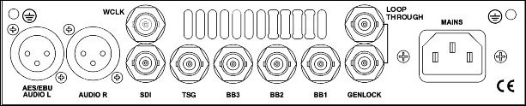

Ordering Information

PT 5201 Compact Varitime TM Sync Generator 9449 052 01001

FOR FURTHER INFORMATION
Contact the PTV sales office in your area or contact us directly:

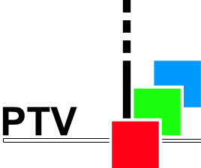

PROTELEVISION
TECHNOLOGIES
SKELMARKSVEJ 4
DK-2605 BRØNDBY,
DENMARK
PHONE.: +45 4329 2300
Fax: ´+45 4329 2424
E-MAIL: ptv@ptv.dk
WEBSITE: http:/www.ptv.dk

9499 496 04111 – 001026
Data change to alteration without notice
Printed in Denmark
® PROTELEVISION TECHNOLOGIES

